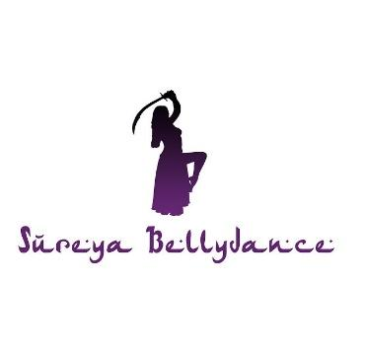
Terms and Conditions
1) Booking Terms and Cancellation Policy
-The amount paid is non-refundable unless the teacher has to cancel the booking.
-Should you miss the workshop or any classes due to no longer being able to attend after your spot has been confirmed, payment made is still non-refundable.
-With any physical exercise, there are risks. It is your responsibility to check with your doctor or healthcare professional if this form of physical exercise is safe for your body before signing up to a class or workshop.
-During the class/workshop, safety and correct body alignment takes priority and Sureya will do her best to demonstrate each movement with emphasis on this. It is however the participants responsibility to listen to their body and not force any movement if it brings them any pain or discomfort. Sureya Bellydance does not take any responsibility for any personal injuries or medical conditions caused as a result of joining these classes or workshops. Each lesson will contain a warm up, conditioning and cool down appropriate for the exercises covered.
-There will be no toleration of any aggressive or violent behaviour in the class or workshop. It is your responsibility to act in a respectful manner towards your teacher, fellow participants and staff at the venue. Failure to do so will result in being expelled from the course and any payments already made will be non refundable.
2) Photography and Filming
- You are welcome to take photographs and videos during our classes or workshops.
- All lessons will be recorded and uploaded to a private Google Drive link which you will have lifetime access to as well as the option to download.
- All recordings of the course are strictly for participants who have signed up only. Under no circumstances may the course content be shared with others who have not signed up or in any public domain.
3) Data protection
-Sureya Bellydance will not disclose your information to third parties except where the law requires, or where you have given your permission to do so.

Please note payment of your deposit is taken as confirmation of agreement to our terms and conditions.

